Mini Project - 3

|  |  |
| --- | --- |
| **Student Name/ID Number:** | Syukur Sidiq Nur Alam bdse-0922-089 |
| **Unit Number and Title:** | ACWD Module 4 – Database Design & Implementation |
| **Academic Year:** | 2023 |
| **Unit Assessor:** |  |
| **Project Title:** | Develop Sample Data, Queries or Report, Test & Document Database |
| **Issue Date:** | 24/01/2023 |
| **Submission Date:** | 24/01/2023 |
| **Internal Verifier Name:** |  |
| **Date:** | 24/01/2023 |

|  |
| --- |
| **Learner declaration** |
| I certify that the work submitted for this assignment is my own and research sources are fully acknowledged.  Student signature: Date: |

|  |
| --- |
| **Purpose of this project** |
| **Purpose of this project**  To demonstrate your capabilities in the following areas:   * Develop Sample Data for Reports * Develop Queries & Report * Test Database * Document Database |
| **Submission Format** |
| 1. Screen capture of Sample Data for Report 2. Queries for generating reports from database 3. Detailed description of Test Methods 4. Documentation of Database |
| **Project Brief & Guidance** |
| **Scenario:**  **Refer to the Project Scenario for the Module Project**  You have been approached by ‘ABC Jobs Pte Ltd’ as a website developer to develop a community portal for Software Developers. The project will be carried over through Module 3, Module 4, Module 5 and Capstone project. For this module the scope is to Design, Develop, Implement & Document Struts Framework Website.  The Scope of the Project is to design a Community Portal Similar to Linkedin.com. Users will be able to register in the portal using the Registration Page. Users of the portal can search for other users using various parameters such as First Name, Last Name, Company Name, City & Country. Users will be able to view the Public Profile of users after searching them. The portal allow users to login, request for forgotten password and Update their profile information  The scope of this mini project is to generate reports, test and document database.  **The overview of the project is as below**  There are 2 types of users in this Community portal. They are   1. Software Programmer 2. Administrator |

|  |
| --- |
| **Software Programmer should be able to perform following functions in the portal**   1. Allow the programmers to register in the portal, show a thank you page & send a registration confirmation email. 2. Search & Find Other Programmers after login and view their profile. 3. Provide Login Page 4. Provide password retrieval functionality. 5. Update their Profile after logging in.   Following Functionality is part of Database Design & Will be enhanced as features as required in the Capstone Project, Depending on time availability.   1. Send Messages to Each Other on the Portal 2. Create Threads & Post Replies to a Thread 3. Post Job Opportunities in the Portal   **Administrator should be able to perform following functions in the portal**   1. Administer user data. 2. Send bulk email inviting programmers to register on the community portal   **The portal consist of the following Key pages (For Reference)**   1. Community Portal Home Page 2. Registration Page 3. Registration Confirmation Page 4. Update Profile Page 5. Search Users Page 6. List Search Results 7. Public Profile Page 8. Registration Confirmation Email 9. Login Page 10. Forget Password Page 11. Design the Forget Password Confirmation Page   Following Functionality is part of Database Design and will not be part of development & Will be enhanced as features are required in the Capstone Project, Depending on time availability.   1. Send Messages 2. Read Messages 3. Post in Message Board 4. List Message Board 5. Read A Thread 6. Post Job Opportunities 7. List Job Opportunities & Responses   **The scope of this assignment**   1. Create test data for all tables suitable for generating reports 2. Design report and Create queries which will be used for generation of meaningful management reports. Present the report in HTML format (1 report) |

1. Discuss briefly test methods you will employ to test and validate the database and brief reasons why you choose each test.
2. Document the database
3. Create a batch script to backup database & schedule it to run every 6 hours using windows task scheduler. Provide the script, along with the screen capture of Windows Task scheduler.
4. Provide a Restoration script in case of failure
5. **Create test data for all tables suitable for generating reports**

**USER**

INSERT INTO `comunity_portal`.`user` (`Id_User`, `Name_user`, `Location`, `Experience`, `current_Job`, `roles`, `Skill`, `Password_user`, `Email`) VALUES ('01', 'Syukur', 'Indonesian', 'IT', 'Software Enginer', 'Admin', 'Software Enginer', 'Syukur123', 'syukur@gmail.com');

INSERT INTO `comunity_portal`.`user` (`Id_User`, `Name_user`, `Location`, `Experience`, `current_Job`, `roles`, `Skill`, `Password_user`, `Email`) VALUES ('02', 'Rahman', 'India', 'IT', 'Software Enginer', 'User', 'Software Enginer', 'Rahman123', 'Rahman@gmail.com');

INSERT INTO `comunity_portal`.`user` (`Id_User`, `Name_user`, `Location`, `Experience`, `current_Job`, `roles`, `Skill`, `Password_user`, `Email`) VALUES ('03', 'Rocky', 'Malaysia', 'IT', 'Software Enginer', 'User', 'Software Enginer', 'Rocky123', 'Rocky@gmail.com');

INSERT INTO `comunity_portal`.`user` (`Id_User`, `Name_user`, `Location`, `Experience`, `current_Job`, `roles`, `Skill`, `Password_user`, `Email`) VALUES ('04', 'Agung', 'Singapore', 'IT', 'Software Enginer', 'User', 'Software Enginer', 'Agung123', 'Agung@gmail.com');

INSERT INTO `comunity_portal`.`user` (`Id_User`, `Name_user`, `Location`, `Experience`, `current_Job`, `roles`, `Skill`, `Password_user`, `Email`) VALUES ('05', 'Kemal', 'Saudia Arabia', 'IT', 'Software Enginer', 'User', 'Software Enginer', 'Kemal123', 'Kemal@gmail.com');

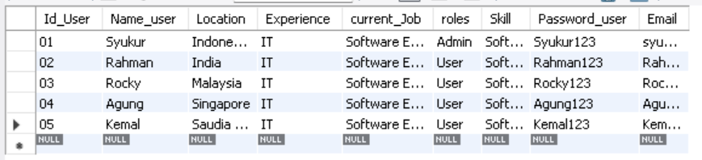

**JOB**

INSERT INTO `comunity_portal`.`job` (`location`, `Id_Job`, `company`, `title`, `Job_Description`) VALUES ('indonesia', '01', 'ABC.jOb', 'Software Enginer', 'hearing a programmer user');

INSERT INTO `comunity_portal`.`job` (`location`, `Id_Job`, `company`, `title`, `Job_Description`) VALUES ('Singapore', '02', 'Lithan', 'Teacher', 'hearing a programmer user');

INSERT INTO `comunity_portal`.`job` (`location`, `Id_Job`, `company`, `title`, `Job_Description`) VALUES ('Malaysia', '03', 'XYZ.job', 'Software Enginer', 'hearing a programmer user');

INSERT INTO `comunity_portal`.`job` (`location`, `Id_Job`, `company`, `title`, `Job_Description`) VALUES ('Indonesia', '04', 'shopee', 'Software Enginer', 'hearing a programmer user');

INSERT INTO `comunity_portal`.`job` (`location`, `Id_Job`, `company`, `title`, `Job_Description`) VALUES ('Indonesia', '05', 'Tokopedia', 'Software Enginer', 'hearing a programmer user');

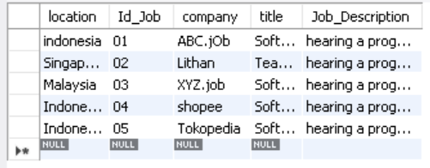

**Bulk_Email**

INSERT INTO `comunity_portal`.`bulk_email` (`Description_Email`, `Id_Email`, `To_Email`, `Subject_Email`, `Id_Administator`) VALUES ('its the special code', '01', 'syukur', 'send code', '01');

INSERT INTO `comunity_portal`.`bulk_email` (`Description_Email`, `Id_Email`, `To_Email`, `Subject_Email`, `Id_Administator`) VALUES ('its the special code', '02', 'kemal', 'send code', '02');

INSERT INTO `comunity_portal`.`bulk_email` (`Description_Email`, `Id_Email`, `To_Email`, `Subject_Email`, `Id_Administator`) VALUES ('its the special code', '03', 'rocky', 'send code', '03');

INSERT INTO `comunity_portal`.`bulk_email` (`Description_Email`, `Id_Email`, `To_Email`, `Subject_Email`, `Id_Administator`) VALUES ('its the special code', '04', 'rahman', 'send code', '04');

INSERT INTO `comunity_portal`.`bulk_email` (`Description_Email`, `Id_Email`, `To_Email`, `Subject_Email`, `Id_Administator`) VALUES ('its the special code', '05', 'asep', 'send code', '05');

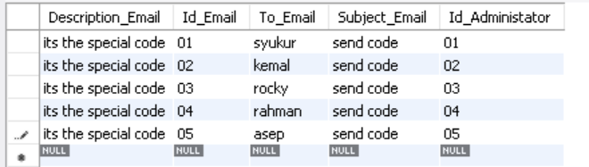

1. **Design report and Create queries which will be used for generation of meaningful management reports. Present the report in HTML format (1 report)**

**Thread**

INSERT INTO `comunity_portal`.`thread` (`Id_User`, `author`, `Thread_name`, `Description_Thread`, `Id_Thread`) VALUES ('01', 'syukur', 'party', 'come join us, lets party', '001');

INSERT INTO `comunity_portal`.`thread` (`Id_User`, `author`, `Thread_name`, `Description_Thread`, `Id_Thread`) VALUES ('02', 'reihan', 'discussion', 'we have issue come here to discussion', '002');

INSERT INTO `comunity_portal`.`thread` (`Id_User`, `author`, `Thread_name`, `Description_Thread`, `Id_Thread`) VALUES ('03', 'rahman', 'hanggout', 'im borring lets hanggout', '003');

INSERT INTO `comunity_portal`.`thread` (`Id_User`, `author`, `Thread_name`, `Description_Thread`, `Id_Thread`) VALUES ('04', 'kemal', 'seminar', 'let\'s increase knowledge by attending seminars', '004');

INSERT INTO `comunity_portal`.`thread` (`Id_User`, `author`, `Thread_name`, `Description_Thread`, `Id_Thread`) VALUES ('05', 'asep', 'learning', 'hey i have nice knowledge come here', '005');

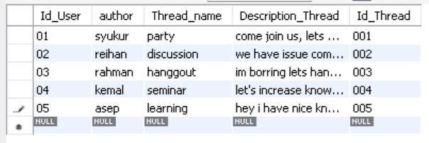

**Message**

INSERT INTO `comunity_portal`.`message` (`reciver`, `sender`, `Date_Time`, `Id_Message`, `Id_User`) VALUES ('syukur', 'rahman', '01 jan 2023', '01', '02');

INSERT INTO `comunity_portal`.`message` (`reciver`, `sender`, `Date_Time`, `Id_Message`, `Id_User`) VALUES ('asep', 'kemal', '02 jan 2022', '02', '01');

INSERT INTO `comunity_portal`.`message` (`reciver`, `sender`, `Date_Time`, `Id_Message`, `Id_User`) VALUES ('rocky', 'agung', '03 jully 2022', '03', '03');

INSERT INTO `comunity_portal`.`message` (`reciver`, `sender`, `Date_Time`, `Id_Message`, `Id_User`) VALUES ('rakha', 'reihan', '11 agust 2022', '04', '05');

INSERT INTO `comunity_portal`.`message` (`reciver`, `sender`, `Date_Time`, `Id_Message`, `Id_User`) VALUES ('ajri', 'syukur', '11 jan 2023', '05', '04');

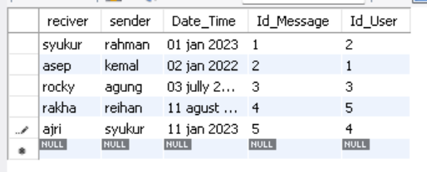

**ADMINISTRATOR**

NSERT INTO `comunity_portal`.`administator` (`Id_Administator`, `Password_admin`, `Name_Admin`) VALUES ('01', 'admin01', 'admin1');

INSERT INTO `comunity_portal`.`administator` (`Id_Administator`, `Password_admin`, `Name_Admin`) VALUES ('02', 'admin02', 'admin2');

INSERT INTO `comunity_portal`.`administator` (`Id_Administator`, `Password_admin`, `Name_Admin`) VALUES ('03', 'admin03', 'admin3');

INSERT INTO `comunity_portal`.`administator` (`Id_Administator`, `Password_admin`, `Name_Admin`) VALUES ('04', 'admin04', 'admin4');

INSERT INTO `comunity_portal`.`administator` (`Id_Administator`, `Password_admin`, `Name_Admin`) VALUES ('05', 'admin05', 'admin5');

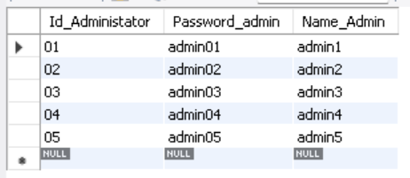

|  |  |  |  |
| --- | --- | --- | --- |
| No | Note | Query | Evidence |
| 1 | All user contact details / to fetch user details | SELECT Id_User , Email,Password_user, Name_user,Skill FROM user ORDER BY Name_user; |  |
| 2 | Company and job information | SELECT CONCAT(Id_User, ". ", Name_user) AS Name, CONCAT(Experience,", ",Skill) AS skill, email AS Email  FROM user  ORDER BY Name_user; |  |
| 3 | rename the job table | SELECT Id_Job, company AS Name_Company, Job_Description AS Description, title AS title_job  FROM job  ORDER BY Id_Job; |  |

1. **Discuss briefly test methods you will employ to test and validate the database and brief reasons why you choose each test.**
2. **Structural Database Testing**
3. Schema Testing

Schema or database testing is vital in ensuring the validity of data received and stored in the database.

|  |  |  |  |  |
| --- | --- | --- | --- | --- |
| No. / Test Cases | Expected Result | Actual Result | Test Result | Evidence |
| 1. Schema Testing: Ensure that the Relationship Schema and EER Diagram are the same in terms of (table name, attributes, primary key, and foreign key) | Both Relationship schema and EER Diagram should be the same | Both the Relationship schema and EER diagram are same | Pass | Screen capture of logical design and physical design (EERD) |

Evidence

**Relationship Schema**

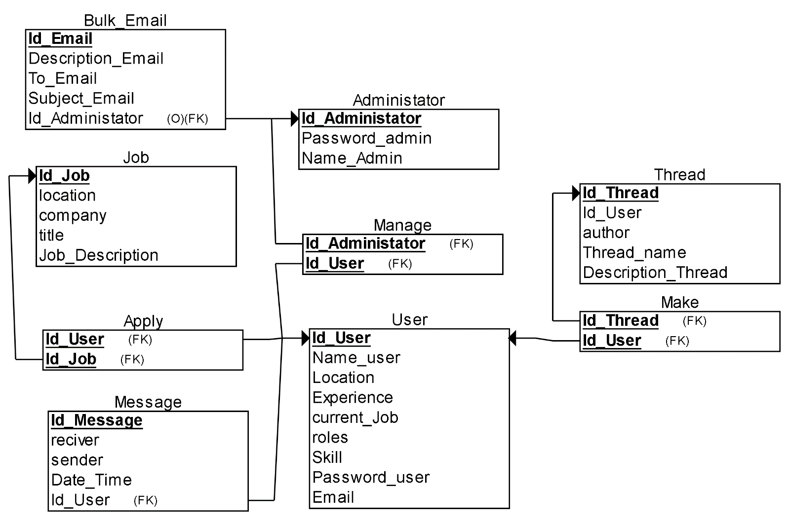

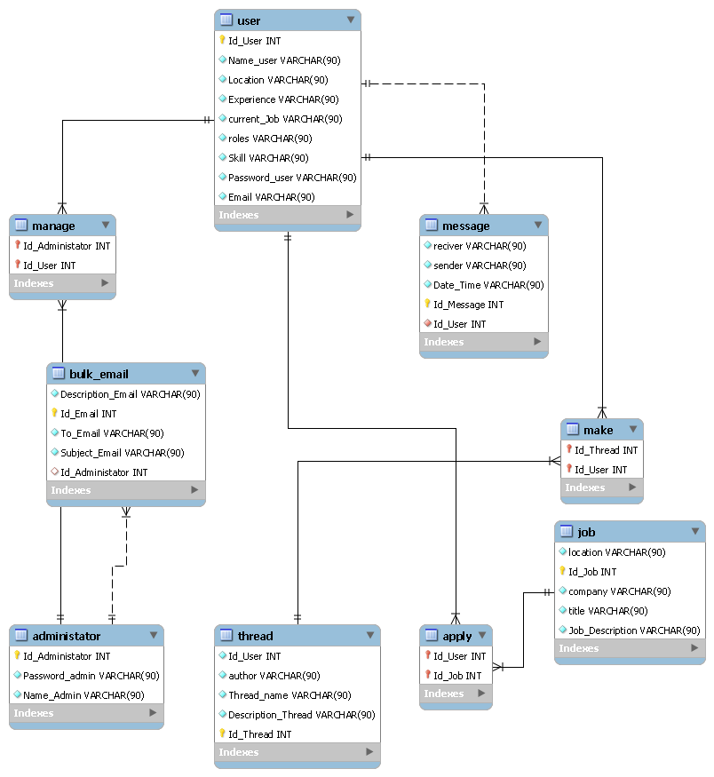

1. **Table/Column Testing**

Every transaction or sequence of operations performed using SQL statement must conform to the ACID properties validation.

|  |  |  |  |  |  |
| --- | --- | --- | --- | --- | --- |
| TestCase ID | Test case | Expected result | Actual result | Pass / Fail | Evidence |
| TC01 | 1. Primary Key testing: Insert duplicate value for primary key column for ‘user’ table | Error message should appear because duplicate value will be inserted into primary key column violating the rule | Error message appear because duplicate value is inserted into primary key column | Pass | Evidence screen capture No TC01 |
| TC02 | checking data size of author table | Error message should appear because data size is less | Error message should appear because data size is too long | Pass | Evidence screen capture No TC02 |
|  | **Not Null Checking :**  Insert into qualification table without filling in the Id_user | an error message will appear because the qualification must have a Id_user or the Id_user cannot be null | Error Message Appear | Pass | Evidence screen capture No TC03 |

**Evidence**

|  |  |
| --- | --- |
| **TC01** |  |
| **TC02** |  |
| **TC03** |  |

1. **Functional Database Testing**

Functional database testing is to test whether data in the database can be accessed and updated by the users and applications, all CRUD.

|  |  |  |  |  |  |
| --- | --- | --- | --- | --- | --- |
| TestCase ID | Test Case | Expected Result | Actual Result | Test Result | Evidence |
| FC001 | 1. Insert record into ‘user’ table | A record should successfully insert into 'user' table. | Record is successfully inserted into ‘user’ table | Pass | FC001 Fig |
| FC002 | 2. update record ‘user’ table | A record should successfully update 'user' table. | Record is successfully updated ‘user’ table | Pass | FC002 Fig |
| FC003 | 3. delete record ‘user’ table | A record should successfully delete 'user' table. | Record is successfully deleted ‘user’ table | Pass | FC003 Fig |

|  |  |
| --- | --- |
| FC001 |  |
| FC002 |  |
| FC003 |  |

1. **Non-Functional Database Testing**

Non –functional specify the quality of a database’s characteristics or attributes based on performance, capacity, data integrity, security, and more. This requirement describes more on how the product works through testing like load, stress, security and others.

**Load Testing**

|  |  |  |  |
| --- | --- | --- | --- |
| No | Test case | Note | Evidence |
| 1 | Auto generate | Test performance of the device for simple test using auto generate from the mysqlslap with 50 users and 10 repetitions. | Load test 1 |
| 2 | custom query from the auto generates | Test performance with custom query using schema from auto generate with 50 users and 10 repetitions. | Load test 2 |

**Load Testing 1**

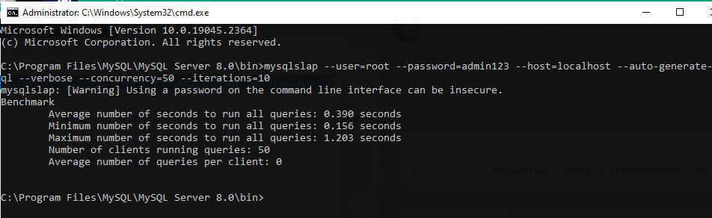

**Load Testing 2**

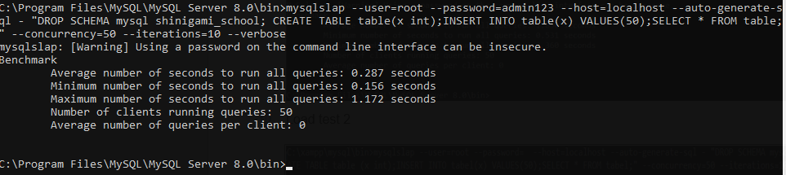

1. **Document the database**

* Open PhpMyAdmin and import query and run

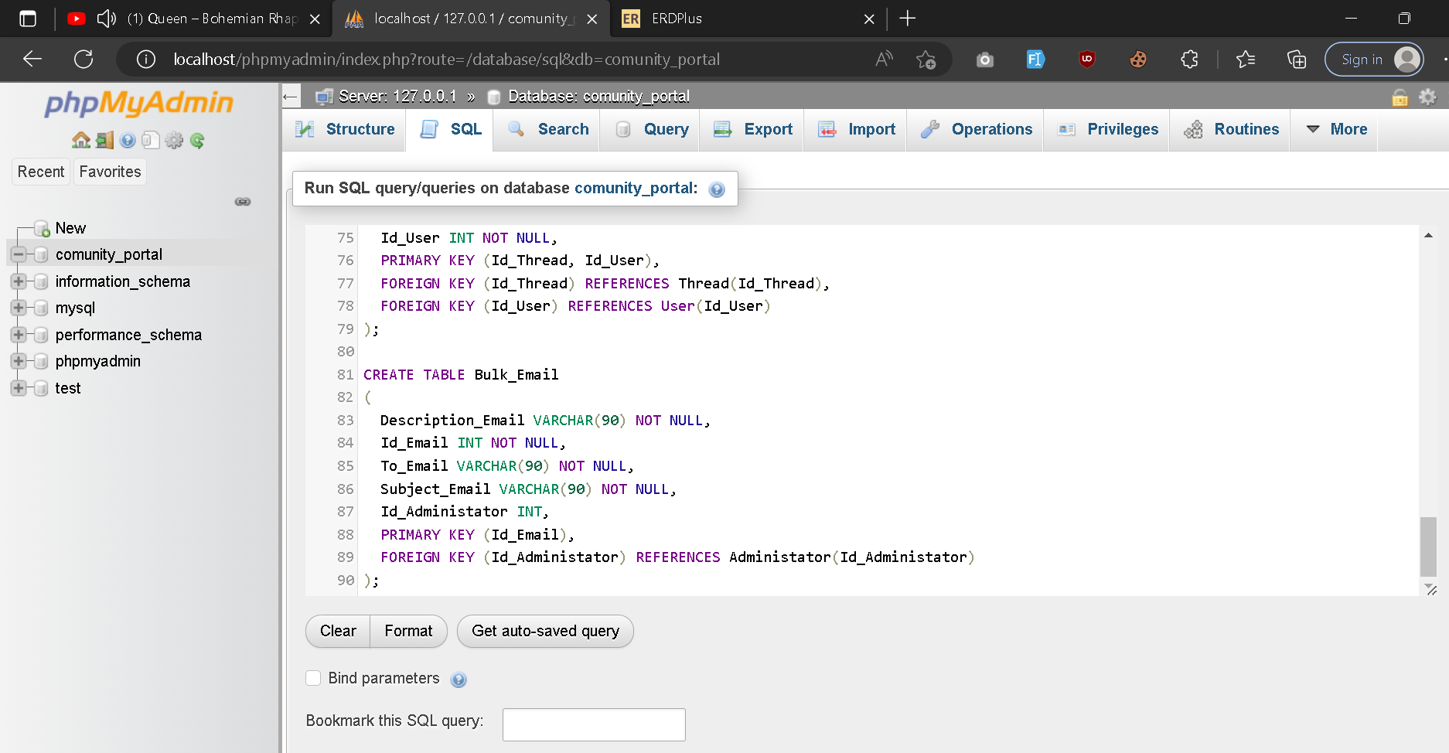

* Check all of the table and click on data dictionary in order to get the documentation

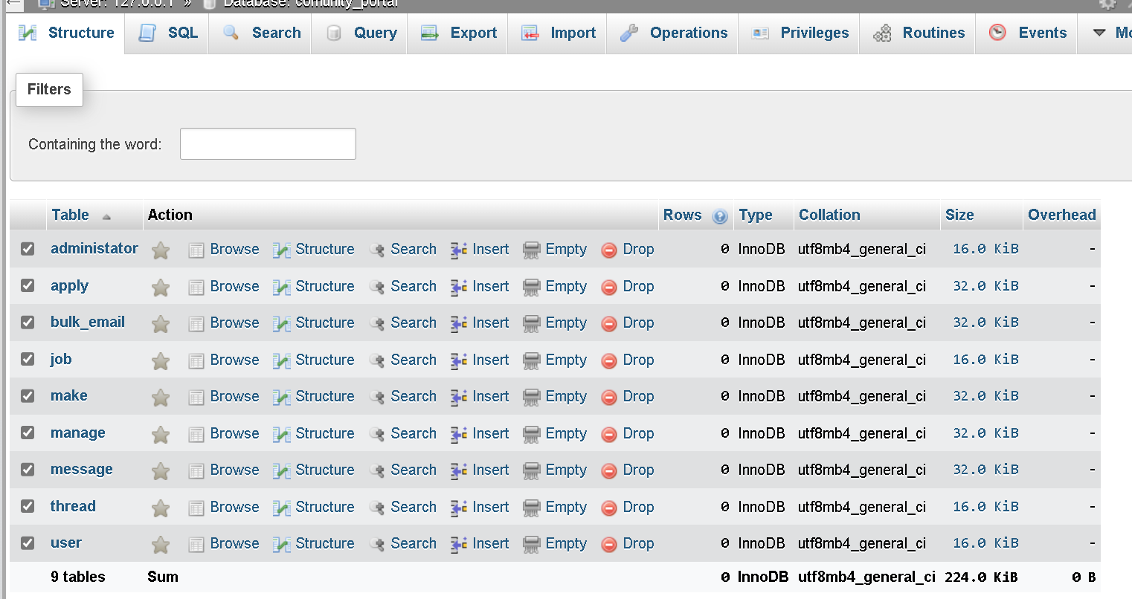

* Print the data dictionary generated

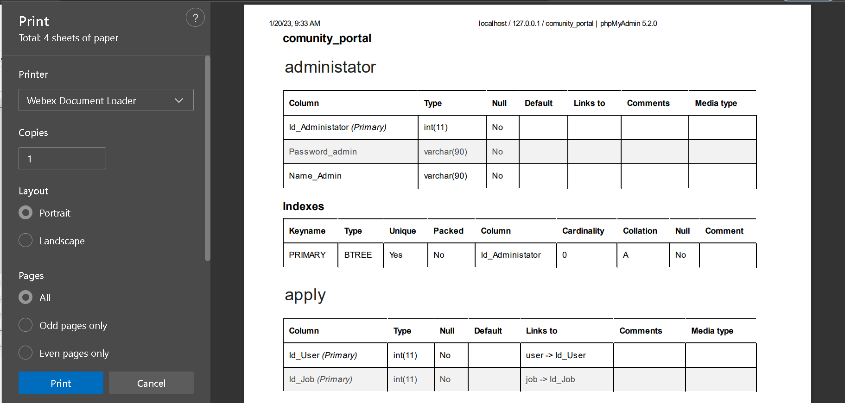

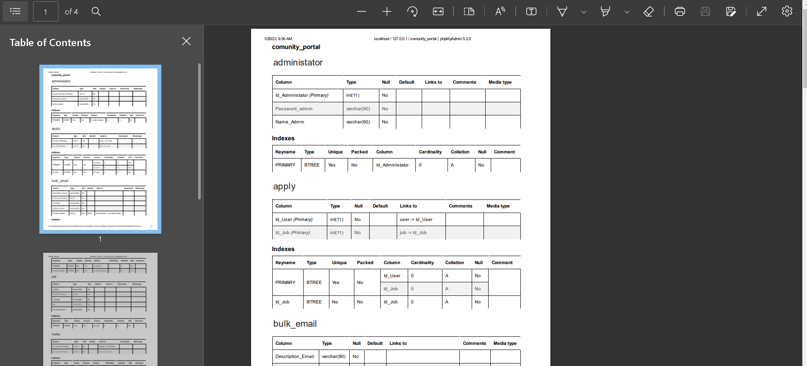

1. **Create a batch script to backup database & schedule it to run every 6 hours using windows task scheduler. Provide the script, along with the screen capture of Windows Task scheduler.**

Create a batch file with backup script

* Open a text file, such as a Notepad or Notepad ++.
* Paste below code in file.
* Save file with .bat extension for example, **autobackup.bat.**

**For single database backup**

1. Create basic Task

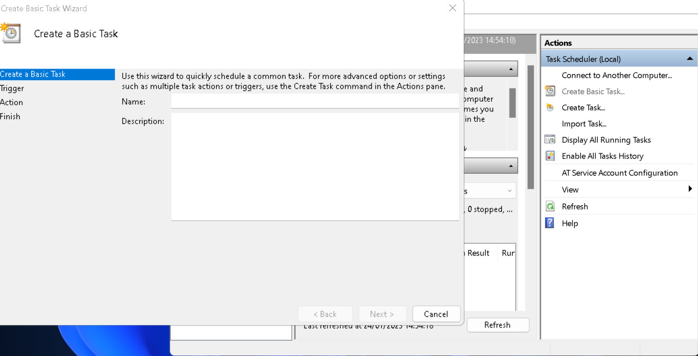

1. Fulfill the form name of the task and description

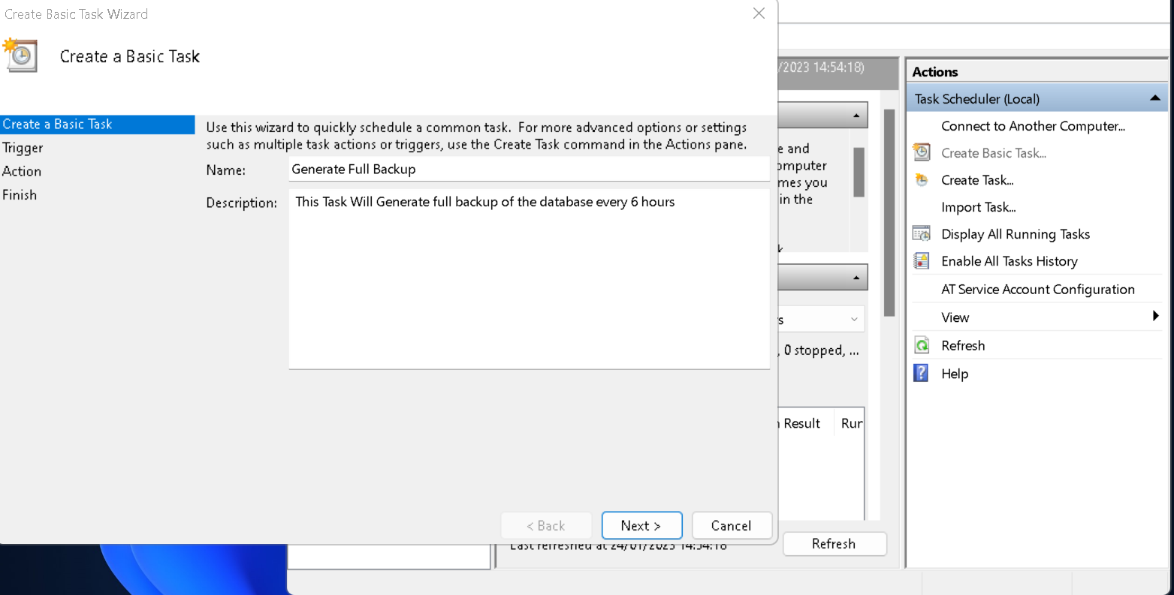

1. Choose Daily

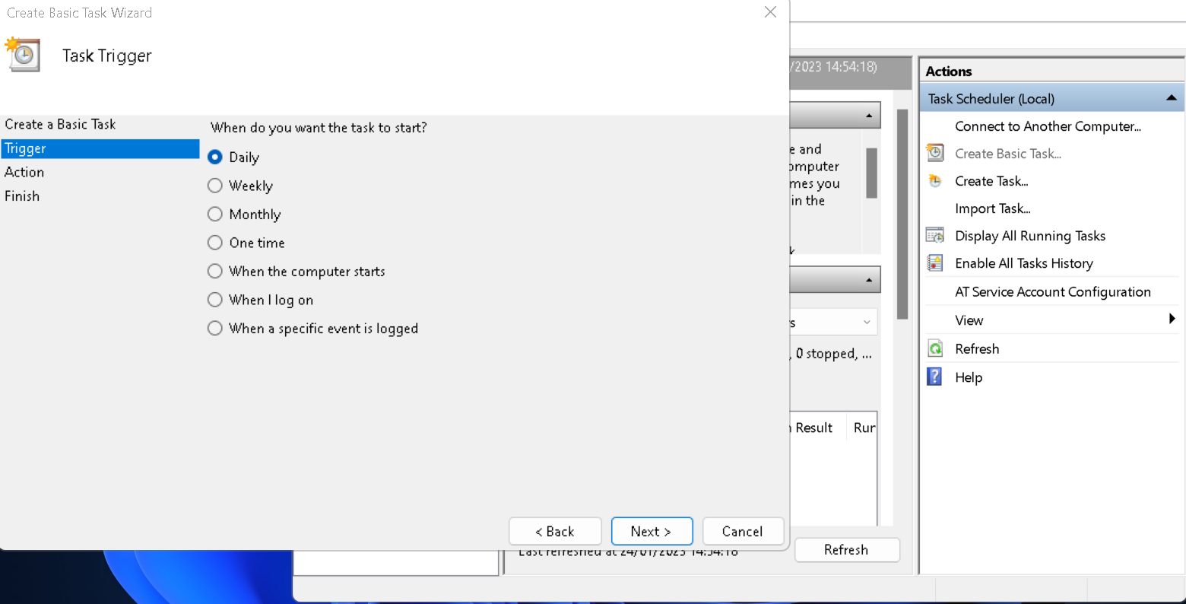

1. Specify in 6:00:00 in time box and 6 in day box

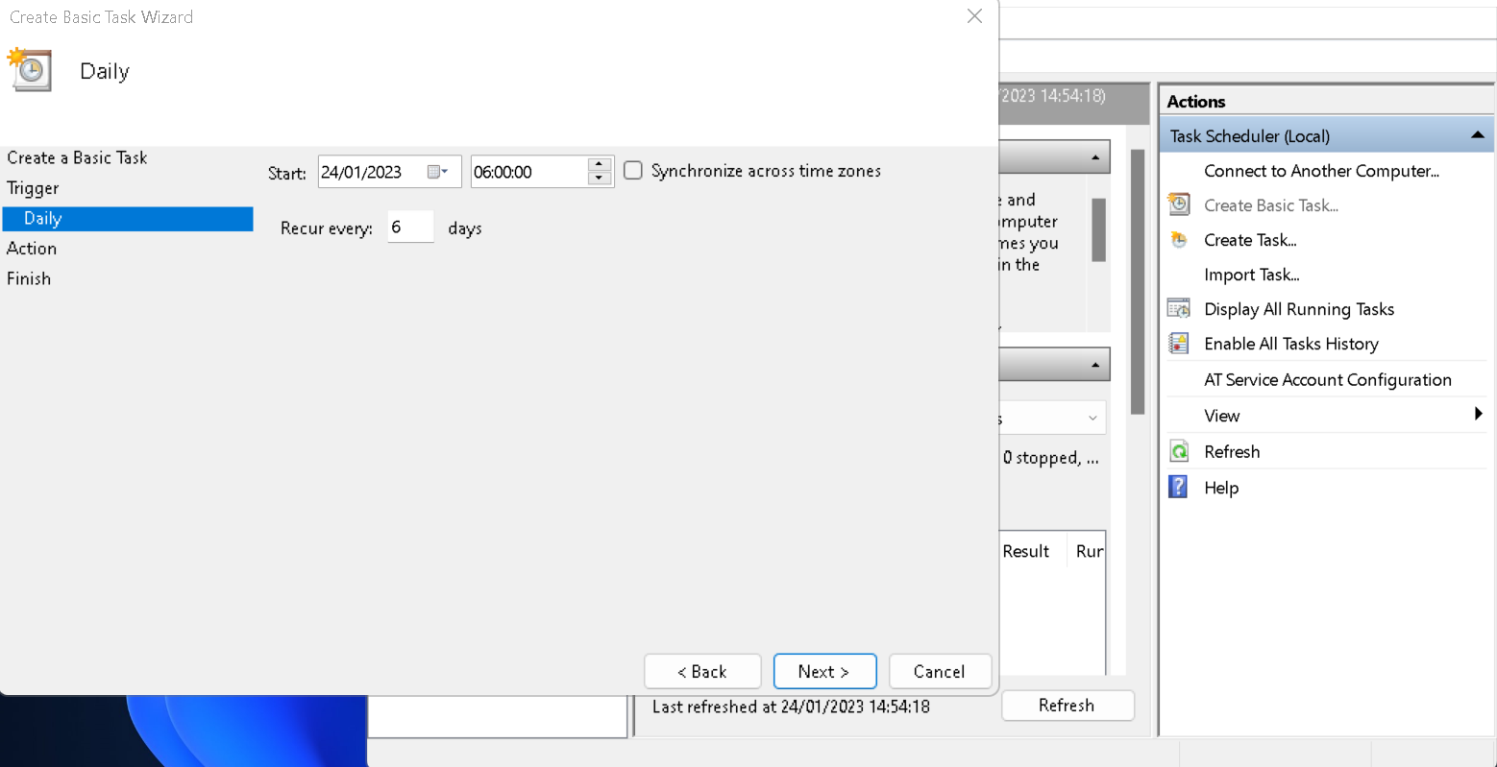

1. Start Program

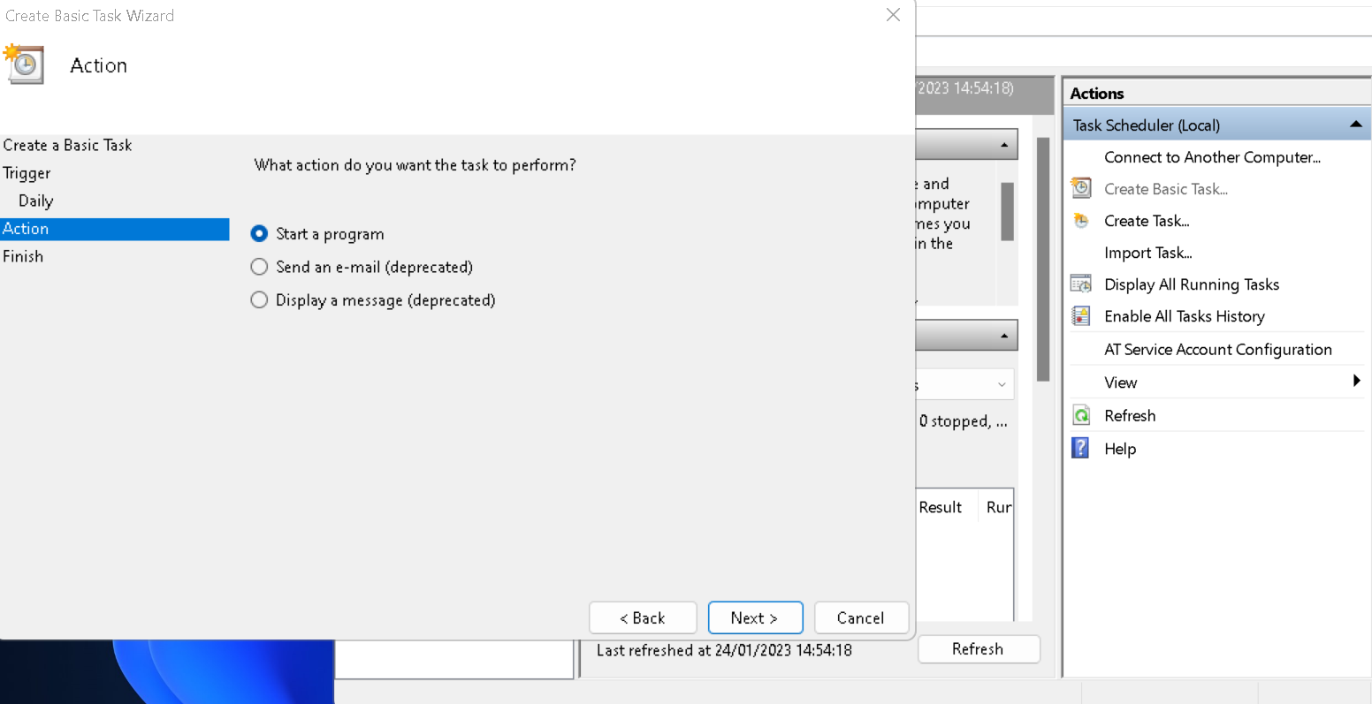

1. And browse the script that we had made before

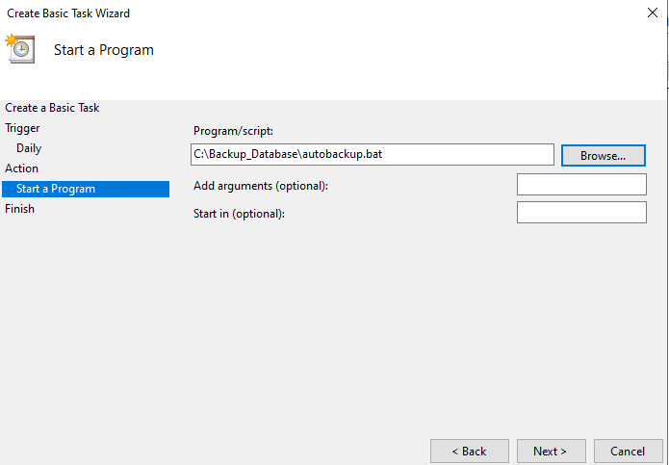

1. Click finish

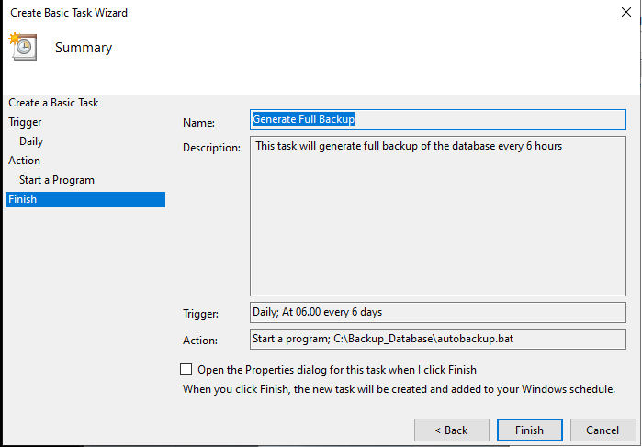

1. You can see the program right here

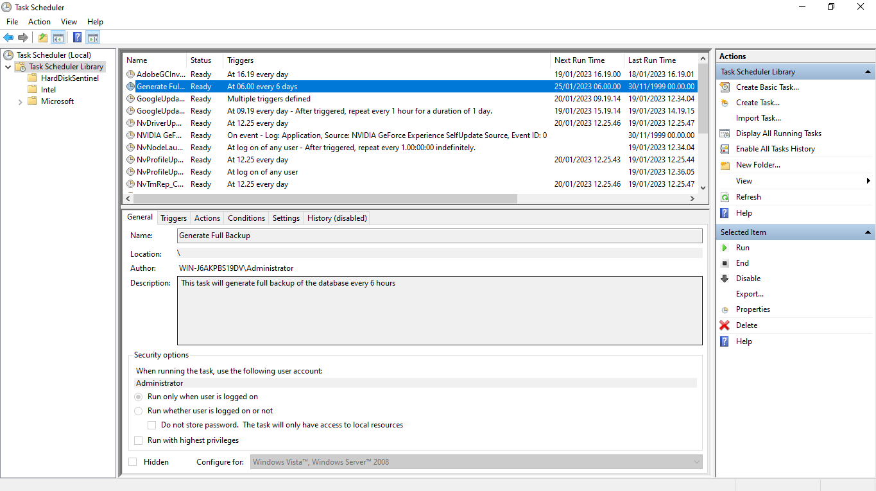

1. Now we can run this program with right click on task

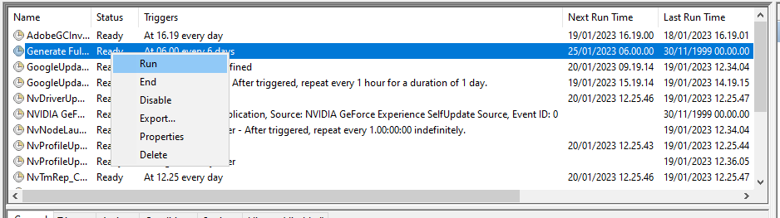

1. Now the program is running

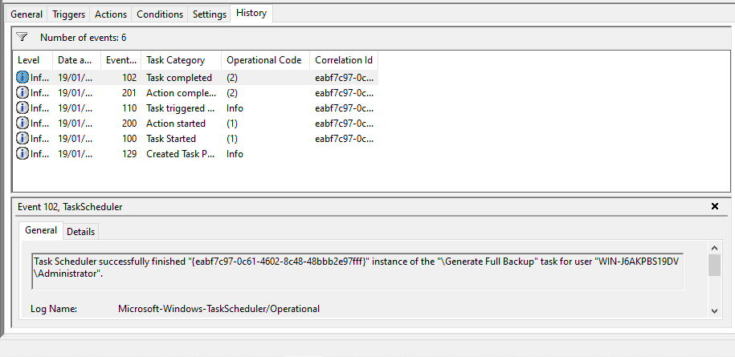

1. **Provide a Restoration script in case**

**This is how to import and export data on MySQL Workbench**

|  |  |
| --- | --- |
| Run Workbench, login to your account, in the left side choose administration and select data export.  Choose schema you want to export |  |
| Run Workbench, login to your account, in the left side choose administration and select data import.  Choose file path the project dump folder |  |
| THIS IS THE RESTORATION SCRIPT CASE |  |